Introduction to Ansible
Ansible is an open-source IT automation engine that automates provisioning, configuration management, application deployment, orchestration, and many other IT processes. Unlike other management tools, Ansible is agentless meaning it installs no software or agents on the remote systems it manages.
It uses YAML (Yet Another Markup Language), a simple English-like language, to describe automation jobs in files called Playbooks.
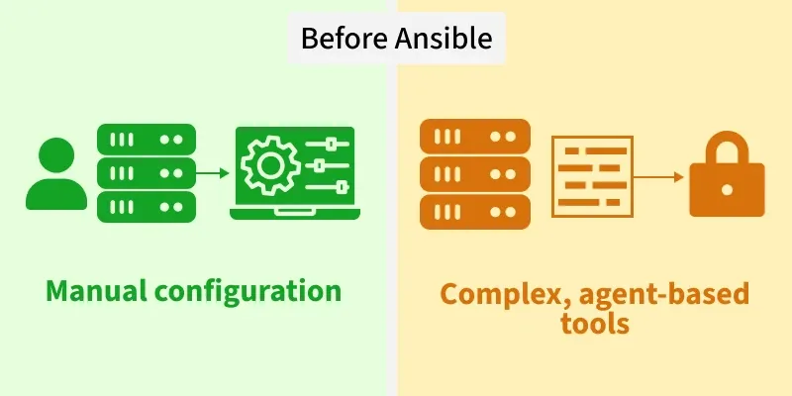
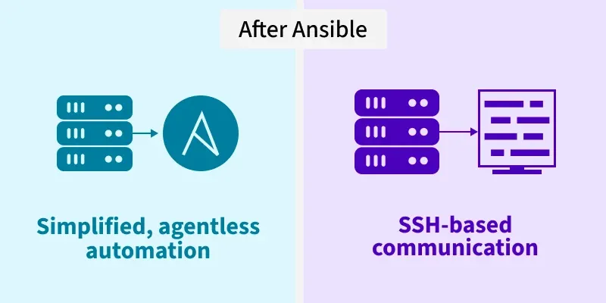
Key Features of Ansible
- Agentless: No software or daemons need to be installed on the managed nodes. It uses existing SSH (Linux) or WinRM (Windows) facilities.
- Idempotency: A core philosophy of Ansible. It ensures that running a playbook multiple times results in the same system state, preventing side effects. If a service is already running, Ansible won't try to start it again.
- Declarative Syntax: You define what the system state should look like (e.g., "Nginx should be present"), and Ansible handles how to achieve it.
- Extensible: Supports hundreds of built-in modules and allows for custom modules written in Python.
Ansible Architecture
The Ansible architecture is straightforward. It consists of a Control Node (where Ansible is installed) and Managed Nodes (the servers you are automating).
1. Control Node
The machine where Ansible is installed and from which you run the playbooks. It can be your laptop or a central server. (Note: Windows is not currently supported as a Control Node).
2. Managed Nodes (Hosts)
These are the network devices (servers, switches, cloud instances) that you want to manage. Ansible creates a connection to these nodes via SSH or WinRM to execute tasks.
3. Inventory
The Inventory is a file (usually located at /etc/ansible/hosts) that lists all the Managed Nodes.
- Static Inventory: A simple text file listing IP addresses or hostnames.
- Dynamic Inventory: Scripts that dynamically query cloud providers (AWS, Azure, GCP) to fetch the list of currently running instances.
4. Modules
Modules are the "tools" in the Ansible toolkit. They are small programs that Ansible pushes to the managed nodes to perform specific tasks (e.g., yum, apt, service, copy, user).
- Core Modules: Maintained by the Ansible team.
- Custom Modules: Written by users for specific tasks.
5. Playbooks
Playbooks are the blueprint of automation. Written in YAML, they define a list of tasks to be executed across a set of hosts
6. Plugins
Plugins extend Ansible’s core functionality. Common examples include:
- Connection Plugins: Handle communication (SSH, WinRM, Docker).
- Callback Plugins: Handle logging and display of output.
How Ansible Works
Ansible works by connecting to your nodes and pushing out small programs, called "Ansible Modules," to them.
The Workflow:
- Create Inventory: Define the IP addresses of the hosts you want to manage.
- Write Playbook: Define the desired state of those hosts in a YAML file.
- Execute: Run the playbook using the ansible-playbook command.
- Connect & Push: Ansible connects to the target nodes (via SSH/WinRM).
- Fact Gathering: Ansible gathers system details (IP, OS version, CPU) from the target; these are called "Facts."
- Execute Modules: Ansible executes the modules defined in the playbook on the remote node.
- Clean Up: Ansible removes the modules after execution and reports the status (Changed, Failed, or OK).

Follow Below Steps to Check and Install Ansible.
Check If Ansible is present
# ansible –version
If not execute below command to install ansible.
#yum install ansible
Once Install you should get following output something like this
# ansible –version
[root@ip-172-31-20-209 ~]# ansible --version
ansible [core 2.15.3]
config file = None
configured module search path = ['/root/.ansible/plugins/modules', '/usr/share/ansible/plugins/modules']
ansible python module location = /usr/lib/python3.9/site-packages/ansible
ansible collection location = /root/.ansible/collections:/usr/share/ansible/collections
executable location = /usr/bin/ansible
python version = 3.9.25 (main, Jul 15 2026, 00:00:00) [GCC 11.5.0 20240719 (Red Hat 11.5.0-5)] (/usr/bin/python3.9)
jinja version = 3.1.4
libyaml = True
So now the Ansible is configured .
Now we will write our first Playbook.
#vi nginx_install.yml
---
- name: Install and configure NGINX on CentOS 8
hosts: localhost
become: yes

tasks:
- name: Install NGINX
yum:
name: nginx
state: present

- name: Start and enable NGINX service
systemd:
name: nginx
state: started
enabled: yes

Now execute the following play book.
#ansible-playbook nginx_install.yml
Nginx should be installed on the server.
Now we will use inventory file to install nginx.
Create inventory file as follows
# vi inventory.ini
[localhost]
127.0.0.1 ansible_ssh_private_key_file=~/.ssh/id_rsa
Now generate sshk for password less login by pressing enter.
[root@ip-172-31-20-209 .ssh]# ssh-keygen
Generating public/private rsa key pair.
Enter file in which to save the key (/root/.ssh/id_rsa):
Enter passphrase for "/root/.ssh/id_rsa" (empty for no passphrase):
Enter same passphrase again:
Your identification has been saved in /root/.ssh/id_rsa
Your public key has been saved in /root/.ssh/id_rsa.pub
Now copy the contents of /root/.ssh/id_rsa to /root/.ssh/authorized_keys
[root@ip-172-31-20-209 .ssh]# ll authorized_keys
-rw-------. 1 root root 1161 Aug 12 05:30 authorized_keys
#vi /root/.ssh/id_rsa
Copy the content using mouse , close file and open below file and paste the copied content in it at the end.
#vi /root/.ssh/authorized_key
# Now execute the ansible command as follows.
#ansible-playbook -i inventory.ini nginx_install.yml

